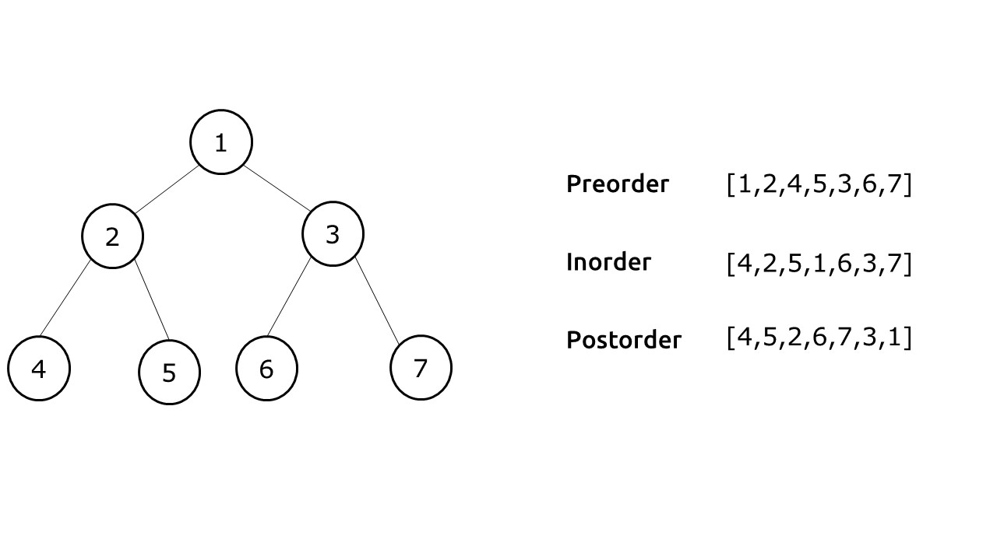

Please provide the order of nodes returned by the following traversal methods:

| Preorder: |  |
| --- | --- |
| Inorder: |  |
| Postorder: |  |

Provide the sum of each traversal if you include only the nodes traversed before visiting node 1.

(e.g., if a traversal returns [3, 6, 5, 1, …], sum = 3 + 6 + 5 = 14)

| Preorder: |  |
| --- | --- |
| Inorder: |  |
| Postorder: |  |

| Which traversal has the minimum final node? |  |
| --- | --- |
| (e.g., if traversal A finishes with node 5 and traversal B finishes with node 2, traversal B has the minimum final node) |  |